6-Traits Study Guide for Hangman’s Gold by Sneed B. Collard III
Study Guide by Vicki Spandel
Link: http://sixtraitgurus.wordpress.com/2011/11/10/hangmans-gold-by-sneed-collard/
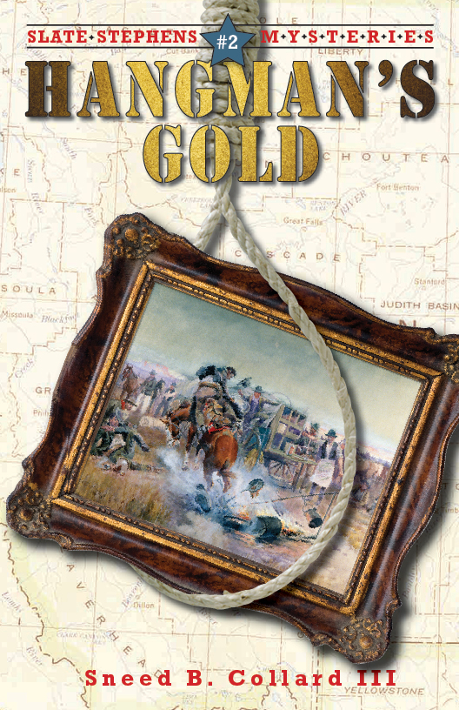
1. Background: How many of your students know where Bannack, Montana is? Locate it on the map. Ask them to imagine what life in this very tiny town might have been like in 1863 (when the gold rush was at its peak). At that time, 3,000 people inhabited Bannack. Talk about the various phenomena (not just gold rushes, but other factors) that can cause towns to boom, then just fade away. The town of Bannack or the gold rush itself may make subjects for further research by interested students.
2. The author’s research: As you share the book, talk about what the author needed to know to write this book. What different kinds of research did he do to prepare for writing? (Be sure to share “Researching Bannack, Gold, Vigilantes, and Charles Russell” on pages 204-205.) How is Collard’s approach to research similar to or different from the approaches used by students in your class? Discuss this. What does really good research require–and why is it important even for narrative? Why can’t writers pull everything from their imagination?
3. Leads and conclusions: Pay close attention to the leads and conclusions for individual chapters. Reread some of the conclusions aloud as you go. What effect do they have on the reader? Do they cause us to make predictions? Do they effectively pull us into the next chapter? What about the leads? Do they follow a pattern, or is each one different? Ask students to identify one or two leads or conclusions they find especially effective and discuss each one. (Note: The Common Core Standards for Reading require students to identify specific passages from literature to support assertions or opinions about that literature. Having students search for specific passages requires them to go beyond a general impressionistic response.)
4. New and intriguing words: It’s said that author Sneed Collard often asks his readers to stretch a little to learn new words. Do your students feel this is true? Did they encounter any words they did not know right away? Talk about their strategies for dealing with new words. Do they generally (1) read on, hoping to make sense of the passage; (2) look up the meaning in a dictionary or thesaurus; (3) ask someone for help; (4) try to figure out the meaning from context (the way the writer uses the word); or (5) make a marginal note and plan to come back later? Which of these strageties are most helpful?
5. The hows and whys of fluency: Have students find a passage they feel is especially fluent (readable) and share it aloud with a partner or in a writing circle. As a class, brainstorm some of the strategies Collard uses to make his writing particularly fluent. Among other things, students may notice the striking variety in sentence length and structure, as well as strong transitional beginnings that link ideas in thoughtful, logical ways. To test the power of these transitions, try writing sentences from a given passage individually on sentence strips. Then mix them up and have students try to re-order them. The easier they find this exercise, the stronger the organizational flow. As a follow-up, have students try this with their own writing–only this time trading with a partner. (Note: Passages should be no more than six sentences long for younger readers, and up to twelve sentences for older readers.)
6. Predictions: Ask students whether they found the ending of this book predictable–or surprising. Readers are constantly making predictions about what will happen as they read–whether they are conscious of it or not. Is it good to be able to predict an ending–or do they think most readers prefer surprises? Why? If they had the option to change the ending of this book, what would they like to see happen? Write some short alternative endings and share them in writing circles. Have students choose one or two favorites to share with the whole class.
7. The importance of dialogue: It’s said that dialogue can serve any of three functions: (1) It advances the action; (2) It shows something important about the character(s); or (3) It creates a certain mood for the scene. Have students find examples of dialogue that serves any or all of these purposes. Perform the dialogue aloud (This can take a couple of practice readings). How does it sound? Would your students make any changes? Write these down. Note: Professional actors make changes in dialogue all the time, even when the writing is strong. Why do you suppose they do this? What do those changes reflect?
8. Characters: Talk about the characters in this book. Is there one your students would like to have for a friend? In which specific scenes do we learn the most about various characters? Do we need to see a character in action–as opposed to simply having an author describe him or her?
9. Make a movie of it: Imagine Hangman’s Gold as a film. Have students cast the film. Discuss setting. Would it be important to go to the real town of Bannack to make this film? Why? Discuss the opening and closing scenes. What would each be like? What would the audience see or hear during those scenes? Have students identify five or six other “high points” from the story that would need to be included in a film. Note: Screenplays based on books are invariably condensed versions of the original story. This is one of the things that makes the writing of a screenplay so very challenging. Talk about what could be omitted from this story–remembering that some things would have to go as it transitions into a film.
10. Working in a writing circle: One of the most effective ways of working in a writing circle is to identify various roles for each contributor. Here’s a suggestion to suit this piece of literature. In a circle of 5 students, have one student fill each of the following roles: (1) Summarizer–Summarize what happens in the book or in specified chapters; (2) Drama coach–Identify one or two particularly strong passages and perform them aloud for the group, talking about why each works; (3) Wordsmith–Identify two or three interesting or unusual words from the book, define them, and talk about why they’re worth adding to a personal word list; (4) Historian–Look up additional details about Bannack or the gold rush, and relate them to life in modern-day Montana; and (5) Biographer–Research the author, identifying interesting details about his life and other writings to share with the group.

